OAKLYN SOCCER CLUB – FREQUENTLY ASKED QUESTIONS
Updated 8/29/2019

REGISTRATION PAYMENT PLAN
- Payment plans are outlined below and must be paid by cash or check. Online registrations are not eligible for payment plans.

TRAVEL SOCCER
- 50% deposit of total registration fees due prior to Try-Out date.
- 50% balance due by July 1st, 2019.
- No refunds & player must attend a Try-Out.
- *50% deposit will be applied to Rec. Soccer if player decides not to try out for Travel Soccer prior to July 1st. Parent/Guardian must submit, in writing, intention to transfer deposit to Rec. Soccer by July 1st.

RECREATIONAL SOCCER
- 50% deposit of total registration fees due by July 1st.
- 50% balance due by July 21st.
- No refunds.

CLINIC SOCCER
- At this time, payment plans are not available for Tiny Kicks or Mini Kicks Soccer.

TRAVEL SOCCER (SJSL) FAQ
- Can my daughter play?
  - Yes! While we have not yet joined the South Jersey Girls Soccer League, girls are permitted on South Jersey Soccer League teams. Please be aware we cannot have an “all girl” team and your daughter will be playing with and against boys.
- Can you explain the different fees?
  - Registration (the base price to play) = $200
  - Signup Fee (this is per family to help offset our low pricing) = $20
  - Try-Out Fee (for Travel only) = $20
  - Volunteer Fee (reimbursed when you volunteer) = $10
  - TOTAL COST: $250 (see below for early bird discounts)
- What discounts do you offer?
  - The $20 signup fee is per family, not per player.
  - If you register during “early bird signup” you save $50 (pay a total of $200 including all fees when registering early vs. paying a total of $250 including all fees when registering late).
- I attended a parent info session. What discount do I receive for that?
  - Your $20 signup fee will be reimbursed.
- What is included in my registration?
  - A uniform jersey, a moisture-wicking uniform shirt in alternate color (in case our opposing team has the same colors, our team can easily swap), uniform shorts, and socks. Goalies will also receive special shirts and gloves.
- What is not included in my registration?
  - Cleats and shin guards, both required.
- What are the age ranges?
  - We will follow the age brackets released by US Soccer (pictured below). Players can be placed on a team up to 2 levels above his/her age, depending on skill level. At this time we plan to create teams using players age 8-14.
- How competitive is the South Jersey Soccer League?
  - SJSL has different “flights”, this breaks teams into categories based on competitive skill, age, gender, and number of similar teams. In our first year in SJSL we will be placed in a less competitive flight. This means competition is not overly fierce, and gives our players time to get used to SJSL and improve skills.
- When are the games?
  - All SJSL games are held on Sundays. OSC is registered for Fall soccer only at this time.
- Where are the games?
  - Fields are listed here: http://www.sjsl.org/clubsite/?p=20672 . However, our teams may not compete at all locations.
- Will my child get a spot on the Travel Team?
  - We are holding try-outs to assess player skills so we can build appropriate teams. We do not anticipate needing to turn away players, but it is a possibility depending on registration numbers.
- If my child is not selected for the Travel Team, what happens to my money?
  - The fees you paid can be applied to Rec. Soccer with the remaining balance refunded to you. If you choose to switch to Rec. Soccer on your own after uniforms are ordered, there is no refund available for the registration difference.
- I’m not used to Oaklyn having these prices, why is it so high?
  - Our pricing is highly competitive with surrounding towns for travel soccer. Many towns do not include uniforms in registration fees, but OSC does. SJSL requires coach training, additional referees, and other fees above recreational soccer leagues. In exchange, our players will be in a competitive league to better prepare for middle and high school sports that require intense try-outs.
- How can I help?
  - We love volunteers! If you have a child registered to play you can earn back your $10 volunteer fee by helping us with snack stand, banquet, or another activity.
- What is Sports Engine?
  - Sports Engine is the website designated by SJSL to handle official game cards for players and coaches. We are required to enter player information into this system for game eligibility. www.sportngin.com
- What do I, as a parent or guardian, need to do?
  - All guardians during our first year using Sports Engine (and guardians of new players after the first year) will receive an email invitation to “claim” your player’s profile. Please accept this invitation and create an account as a guardian (not as the player). Example of email is below.
  - After your child’s membership is paid by Oaklyn Soccer you will need to complete additional steps below for game day eligibility:
  - Upload a birth certificate or other proof of birth to verify player’s age.
  - Accept the Liability Waiver.
  - Upload a headshot photo of your player. Example of how to upload is below.

RECREATIONAL SOCCER FAQ
- Can you explain the different fees?
  - Registration (the base price to play) = $90
  - Signup Fee (this is per family to help offset our low pricing) = $20
  - Volunteer Fee (reimbursed when you volunteer) = $10
  - TOTAL COST: $120 (see below for early bird discounts)
- What discounts do you offer?
  - The $20 signup fee is per family, not per player.
  - If you register during “early bird signup” you save $25 (pay a total of $95 including all fees when registering early vs. paying a total of $120 including all fees when registering late).
- I attended a parent info session. What discount do I receive for that?
  - Your $20 signup fee will be reimbursed.
- What is included in my registration?
  - Team shirt and socks.
- What is not included in my registration?
  - Cleats, shin guards, and black shorts; required.
- When are the games?
  - All Recreational Soccer games are held on Saturdays.
- Where are the games?
  - Games will rotate between Oaklyn’s fields and other local towns.
- Why did you switch leagues for Rec. Soccer?
  - We left the previous Friendship League because our families were required to travel large distances for games. We believe Rec. Soccer should be a fun and local experience. Therefore, we joined a more localized friendship league including, but not limited to: Audubon, Haddon Heights, Bellmawr.
- What are the age ranges?
  - 7 – 14.
- How can I help?
  - We love volunteers! If you have a child registered to play you can earn back your $10 volunteer fee by helping us with snack stand, banquet, or another activity. We also are usually in need of dedicated coaches and assistant coaches.

CLINIC SOCCER FAQ
- What is Clinic Soccer?
  - Tiny Kicks – age 3. Player and a parent work together on the field to learn basic skills in a fun environment. We focus on skill building and not competitive play.
  - Mini Kicks – ages 4-6. Players work with coaches in smaller groups to learn basic skills in a fun environment.
- When is Clinic Soccer?
  - Saturday mornings for one hour.
- What is included in my registration?
  - A T-Shirt and matching socks.
  - We highly recommend you purchase shin guards and cleats, for safety reasons.
- Why must a parent stay during Tiny Kicks Soccer?
  - At this young age it is difficult to hold a child’s attention for the duration of clinic. Our coaches are all volunteers and we want to make sure their attention is equally distributed to all players. A parent must be present to help your child at all times. Wear sneakers and enjoy the morning together!
- How can I help?
  - We love volunteers! If you have a child registered to play Mini Kicks you can earn back your $10 volunteer fee by helping us with snack stand, banquet, or another activity (Tiny Kicks does not have a Volunteer Fee). We also are usually in need of dedicated coaches and assistant coaches.

TOP SOCCER FAQ
- What is TOP Soccer?
  - TOPSoccer is designed to bring the opportunity of learning and playing soccer to children with special needs. Emphasis is on meaningful participation rather than competition.
- How is it free?
  - A generous sponsorship by We Rock the Spectrum in Audubon NJ and dedicated volunteers.
- Who runs the TOP Soccer program?
  - US Youth Soccer / New Jersey Youth Soccer provide training for Oaklyn’s TOPSoccer coaches.
- What are the age limits?
  - 5 to 19
- How can I help?
  - If you are interested in completing training for the TOPSoccer Buddy Course (age 13+), please email oaklynsoccerclub@gmail.com

GENERAL FAQ
- Can my child play both Travel and Rec. Soccer?
  - Yes! Rec. games are held on Saturdays and Travel games are held on Sundays.
- What is the Volunteer Fee?
  - To encourage family participation in our club we will reimburse your $10 Volunteer Fee when you help at the snack stand, banquet, or other activity requested by OSC.
- Can my child wear his/her glasses on the field?
  - Glasses are not permitted on the field. We suggest purchasing prescription sports goggles for your child if he/she cannot play without vision correction.
- Can my child wear jewelry on the field?
  - Jewelry is not permitted and your child will be removed from the game if worn.
- Do I need to purchase a soccer ball?
  - It’s not necessary! Our coaches all have enough balls for practices and games. If you’d like to purchase a ball to use at home, below is the correct sizing.
  - Clinic: size 3, U9-U12: size 4, U14: size 5.
- How do I determine age group?
  - Birth year registration is determined by the year a soccer season ends. Our soccer club is considered Fall to Spring, so for Fall 2019 the season is considered “ended” in Spring 2020. You can subtract your child’s birth year from the season’s ending year. In the case of a 2019/2020 Season and a child born in 2008, the age would be U12 (2020-2008=12).
  - Players can play on a team up to 2 years above his/her age, depending on skill.
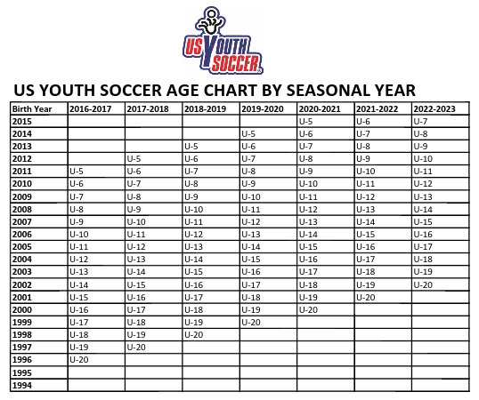

SPORTS ENGINE EXAMPLES

Email invitation to claim account:

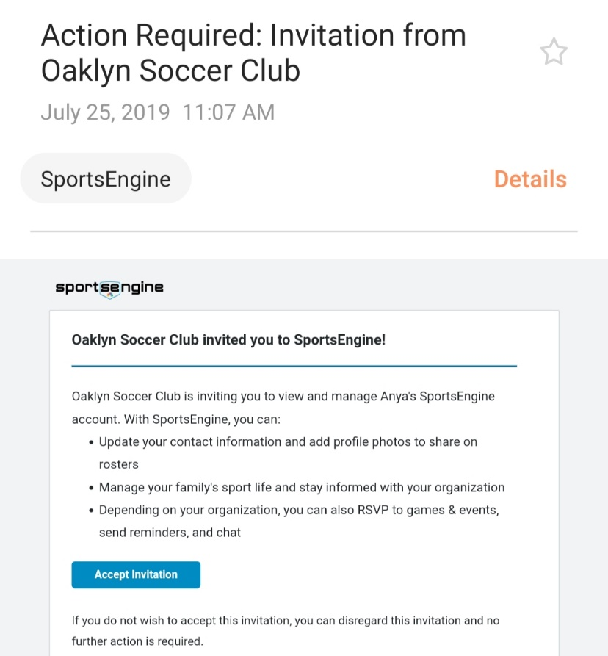

How to upload a headshot photo:

